# **VR Biotech Minigame User Manual**

## **Overview**

The VR Biotech Minigame is a tutorial-based puzzle that simulates a biotech lab environment for students to learn more about correctly using the pipette aid and serological tips to aspirate and dispense liquid from one container to another.

## **Getting Started**

### **System Requirements**

You will need:

* VR Headset (when running the game on the headset)
* Unity Version 2022.3.5f1 (when running the game as a simulation)

### **Starting the Game**

To load the VR Biotech Minigame on a headset, select the Unity icon from the toolbar.

For the Meta Quest headset, the toolbar can be found at the bottom of the landing page. The arrow in the image below points to the Unity icon.

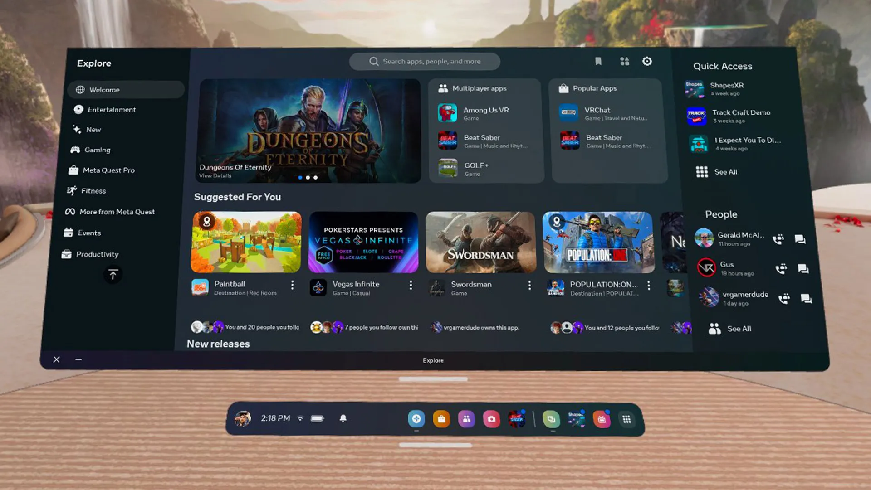

*Figure 1: Home Screen for Meta Quest*

## **Game Controls**

### **Interacting with Buttons**

To interact with the different messages in the dialogue box, point the controller rays to the ‘Next’ button, and click the trigger.

To restart the game, point the controller rays to the ‘Reset’ button and click the trigger.

For the Meta Quest headset, use the upper trigger for both these interactions.

*For other types of headsets, the trigger may be in a different location on the controller. This note may apply to all of the control instructions as various headsets have vastly different control layouts. It may take experimentation to find the mapped equivalent button or control.

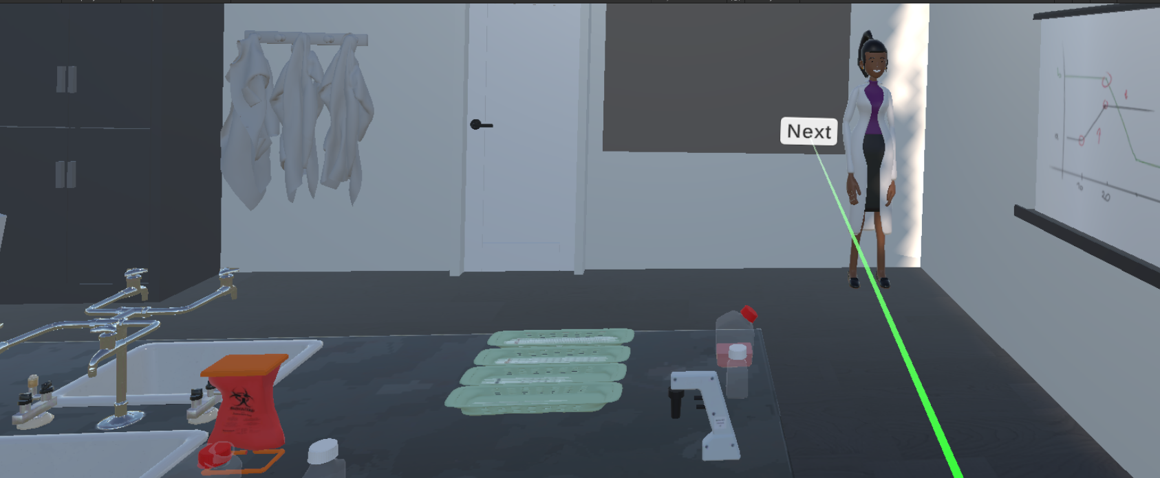

*Figure 2: Interacting with the ‘Next’ button on the dialogue box*

### **Moving around the Scene**

To move around the lab, press down on the joystick on either controller. Then, point the controller to the spot that the player wants to move to, on the floor. Then, click the trigger and the player will be moved to where they pointed on the floor.

For the Meta Quest headset, use the lower trigger for this interaction.

### *Figure 3: Moving from one spot to another*

### **Interacting with the Lab Journal**

To open the lab journal, click on the menu button on the controller. The different pages in the journal have instructions on different tasks that the player needs to complete, feedback on the player’s actions, reminders about lab procedures, and information about controls. To navigate to the different tabs of the notebook point at the label you want to navigate to (Tasks, Feedback, Rules, and Controls) and click the trigger button.

For the Meta Quest headset, the menu button can be found on the left controller and the trigger is the upper trigger.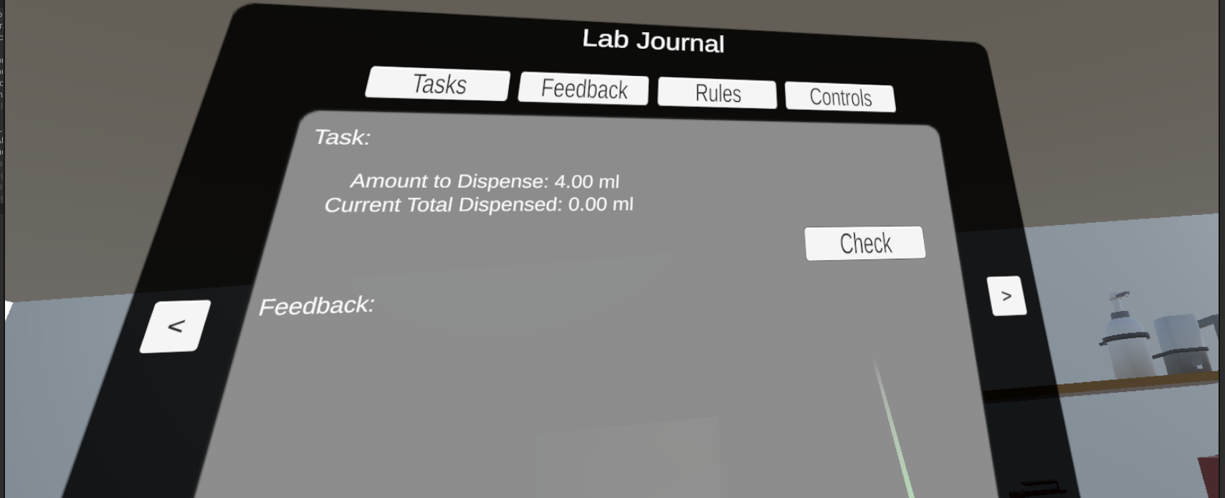

*Figure 4: Tasks Page of the Lab Journal*

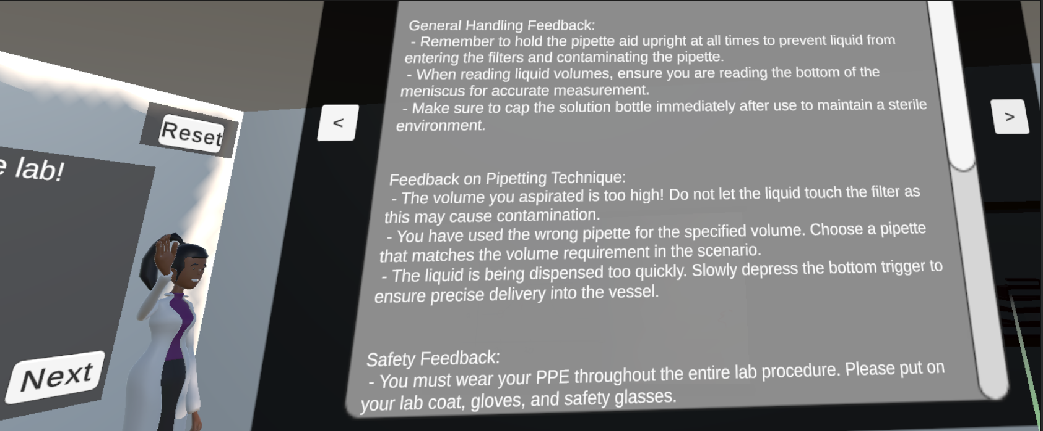

*Figure 5: Feedback Page of the Lab Journal*

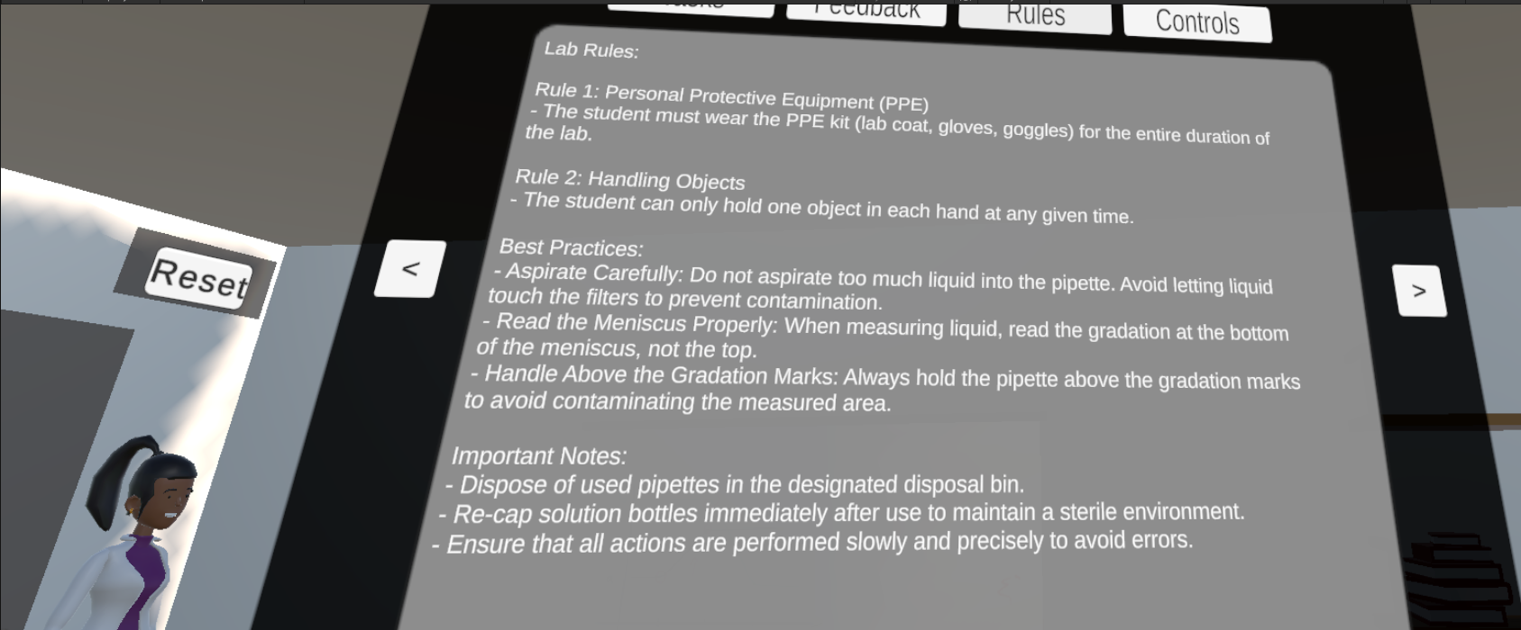

*Figure 6: Rules Page of the Lab Journal*

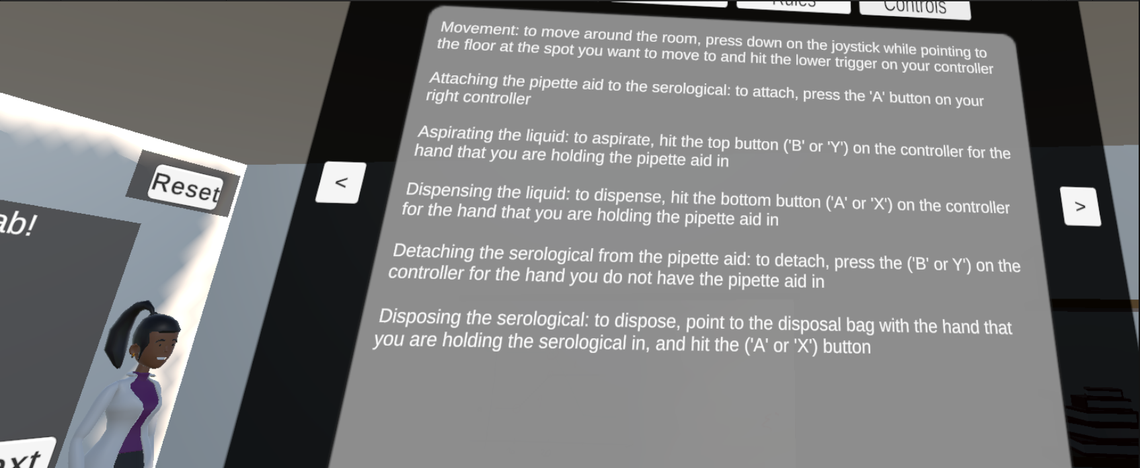

*Figure 7: Controls Page of the Lab Journal*

### **Picking Up Objects**

To pick up an object, point the controller at the object with the rays and click the trigger on the controller in the hand that you want to pick up the object in.

For the Meta Quest headset, use the lower trigger for this interaction.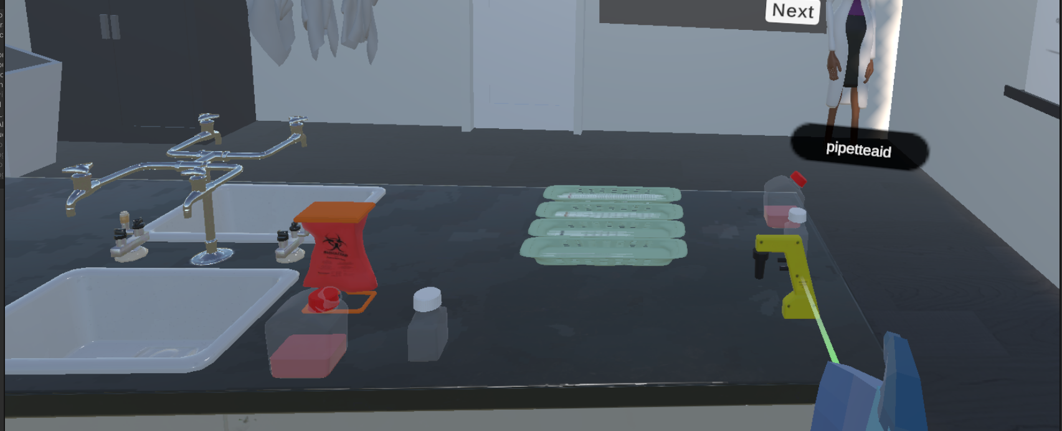

### 

### 

### 

### 

### 

*Figure 8: Picking up the Pipette Aid*

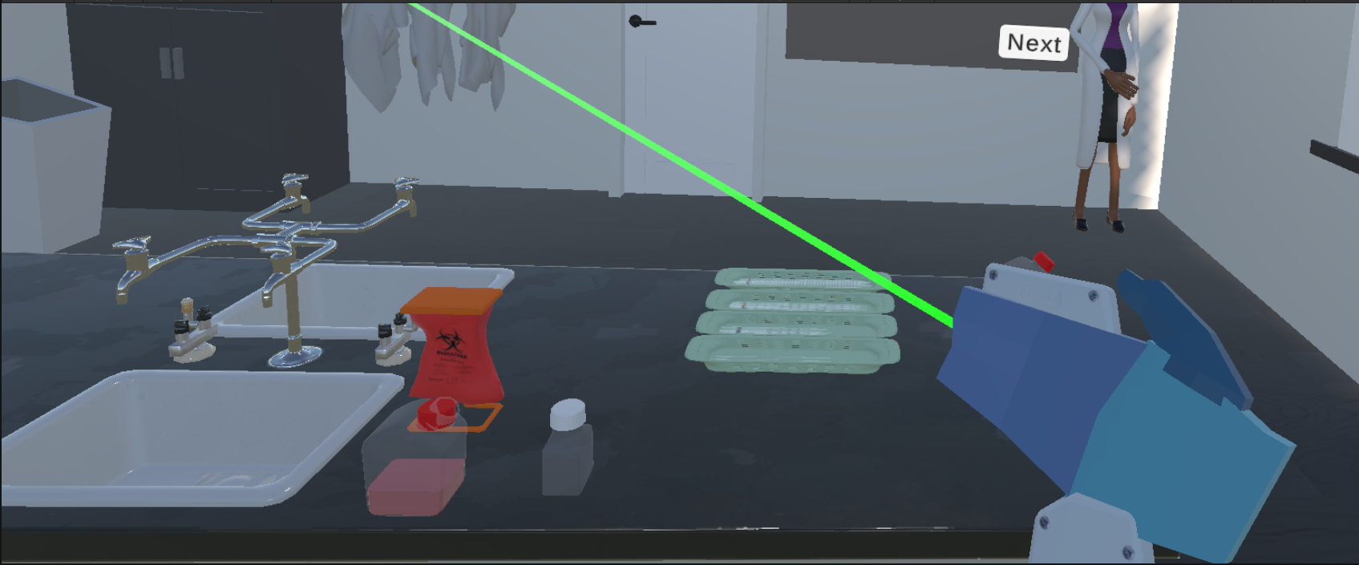

*Figure 9: Pipette Aid in Hand*

### **Attaching Two Objects**

To attach any two objects together, place the two objects close to each other. Then, hit the primary button on the controller.

For the Meta Quest headset, this would be the button labeled ‘A’ on the right controller.

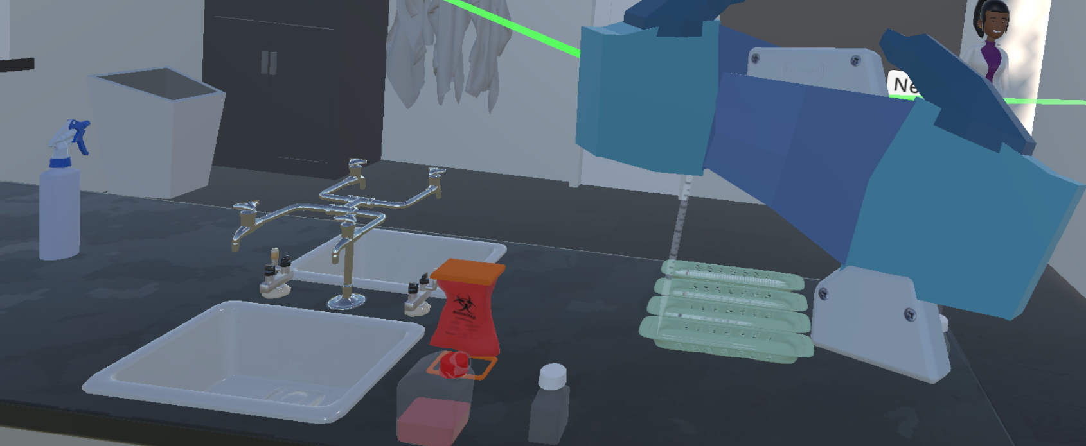

*Figure 10: Placing the pipette aid and the serological together to attach*

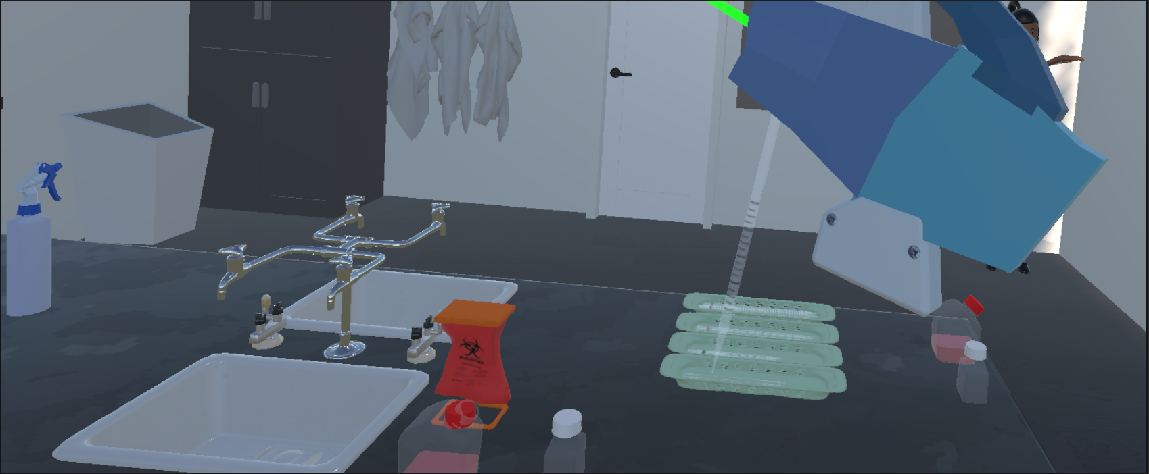

*Figure 11: Serological attached to the Pipette Aid*

### **Detaching Two Objects**

To detach any two objects into each of the player’s hands, point the rays of the controller in the empty hand to the object being detached, and hit the secondary button on the controller in the empty hand.

For the Meta Quest headset, this would be the button labeled ‘Y’ on the left controller.

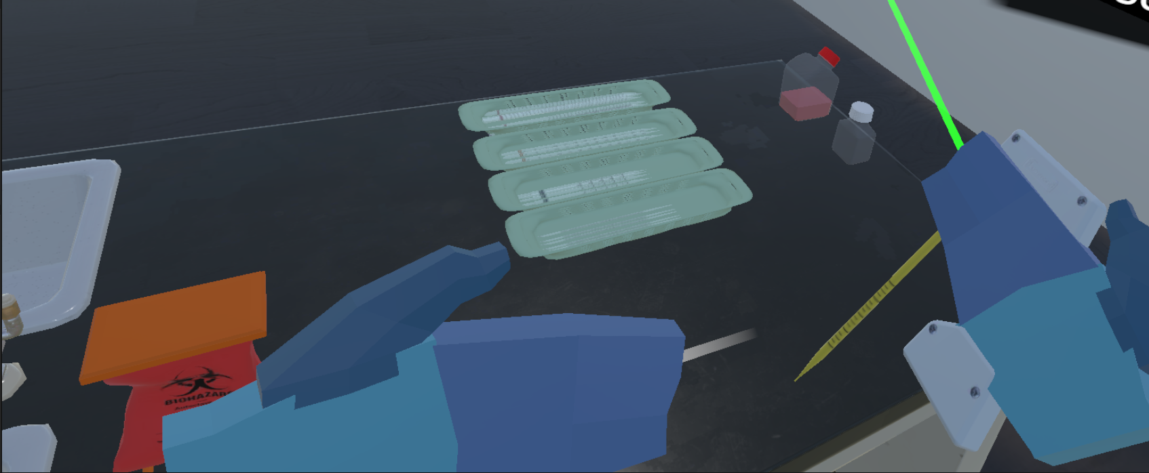

*Figure 12: Pointing to the Serological to detach it from the Pipette Aid*

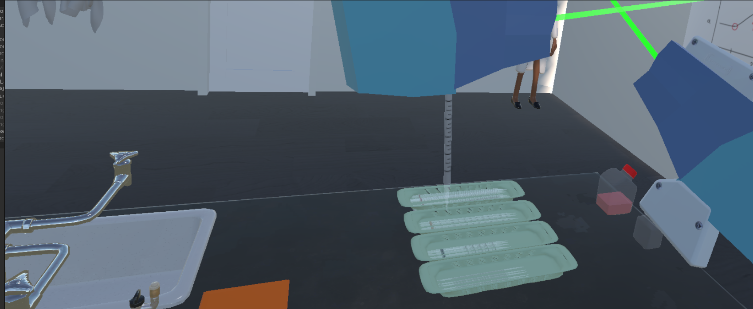

*Figure 13: Detached serological and pipette aid*

### **Aspirating the Liquid**

To aspirate the liquid, hit the secondary button on the controller.

For the Meta Question headset, this would be the button labeled ‘B’ on the right controller or the button labeled ‘Y’ on the left controller.

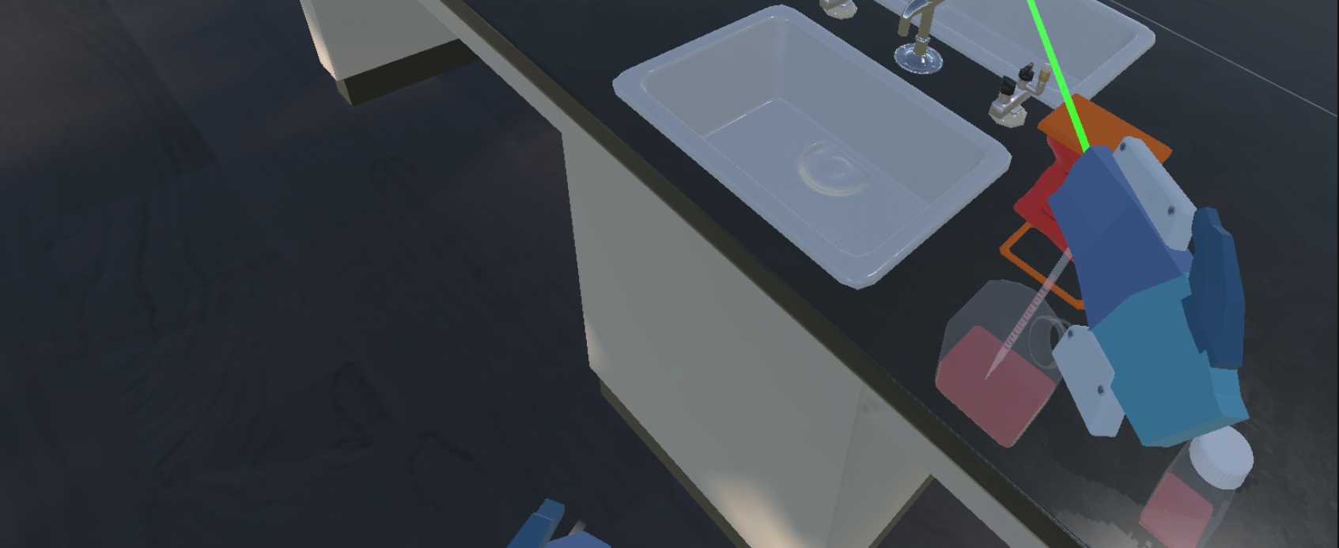

*Figure 14: Aspirating liquid*

### **Dispense the Liquid**

To dispense the liquid, hit the primary button on the controller.

For the Meta Quest headset, this would be the button labeled ‘A’ on the right controller and the button labeled ‘X’ on the left controller.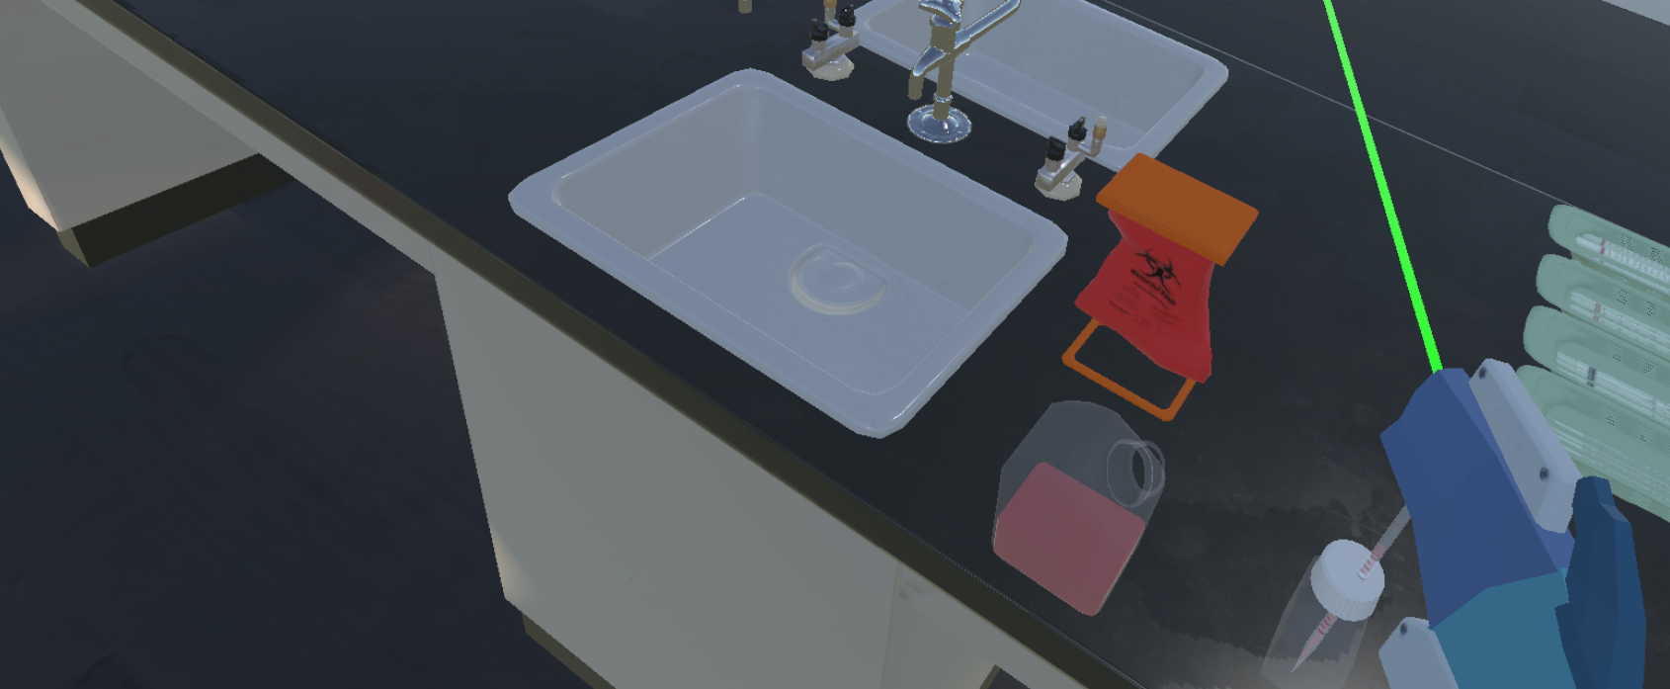

*Figure 15: Dispensing the liquid*

## **Using the Custom Controller**

1. Insert the Meta Quest controller into the controller holder piece on the custom controller by dropping the lanyard in first and depressing the front trigger. Inserting the controller will depress the side trigger, dropping whatever item is in the right hand, meaning the controller should either be inserted before beginning the game or after putting the pipette aid down in the game.
2. Connect the base station to the computer the headset is tethered to using the USB-C cable. It is recommended to do this before starting the game.
3. Power on the custom controller. Check that the green light on the base station labeled “PA” is solid green instead of flashing.
4. Once connected, the custom controller can be used. Use your left hand to interact with the inserted Meta Quest controller to pick up the pipette aid and attach the serological.
   1. The top button aspirates liquid, while the bottom button dispenses liquid. The buttons are progressive and will aspirate/dispense faster the more they are depressed.

*Figure 16: Meta Quest Controller Attached to the Custom Controller*